**Installation for SRS Version 9**

Step 1: Download file at: <http://www.srscomputing.com/wp-content/uploads/2015/10/SRS-Installer9.exe>

Step 2: Run installation file and enter your company installation credentials. These credentials will be provided to you.

Company Code: SRS9_Mountain-WV7744

Activation Code: Mountain-WV!@#

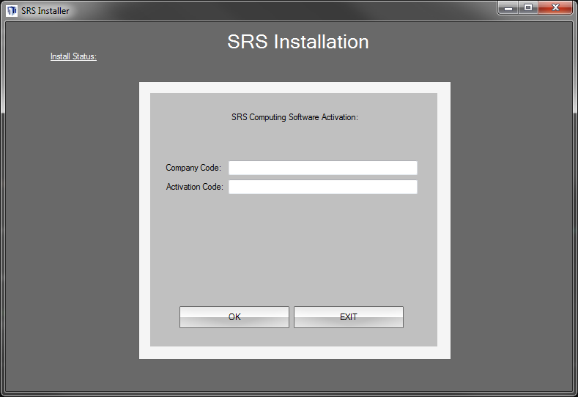

Step 3: Install Procession by clicking on the first button.

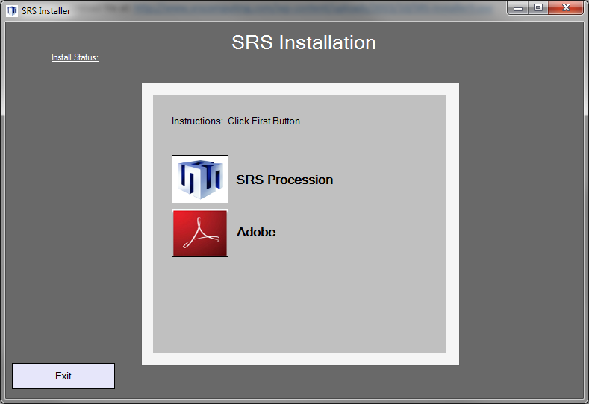

Step 4: Choose your preferred installation location.

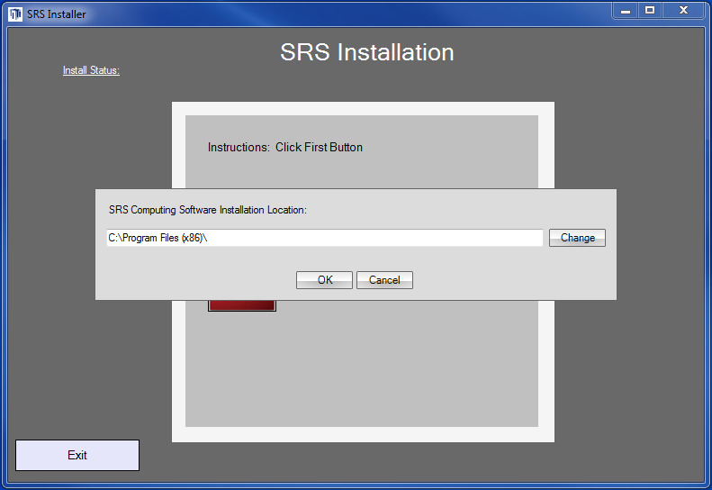

Step 5: Log into the software (This is your typical login you use when opening the SRS software.)

Username: [dtaylor@mtnfg.com](mailto:dtaylor@mtnfg.com)

Password: Allpets1

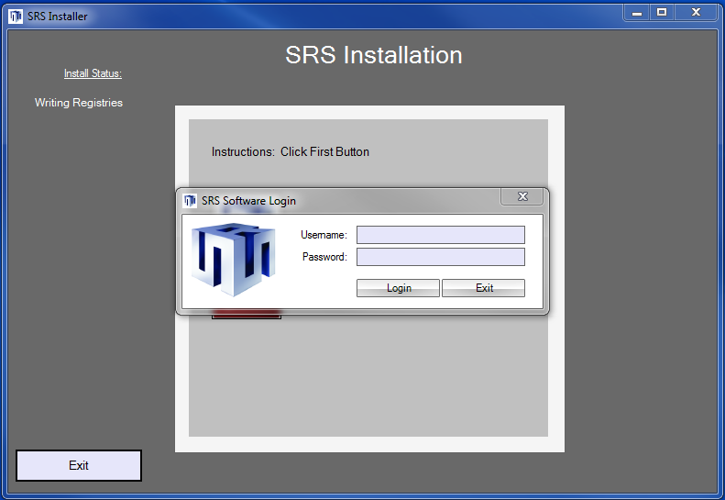

Step 6: After logging into the software, the installer will download the necessary files to complete the installation and install the software.

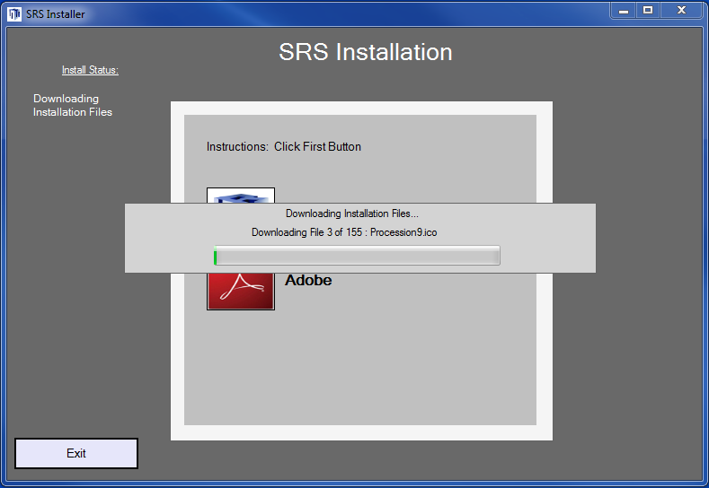

When the installation is complete, you will have a shortcut on the desktop of your computer and you can exit out of the installer.

Step 7: Install Adobe Reader if you do not already have it on your computer.